**Challenge Lab 11 Report**

**Question Description:**

In previous experiment, we have already disabled all the Inboud rules except **Remote** **Desktop (TCP-IN)**, **World Wide Web Services (HTTPS Traffic-In)** and **World Wide Web Services (HTTP Traffic-In)** in firewall on remote machine IP 192.168.3.25. And, in this challenge question, we will disable **Remote** **Desktop (TCP-IN)** and retry **nmap –O –v 192.168.3.25** command to see what happens and what is the difference between previous result and current result.

**Answer:**

At first, we see that **Remote Desktop (TCP-IN)** is still **enabled**.

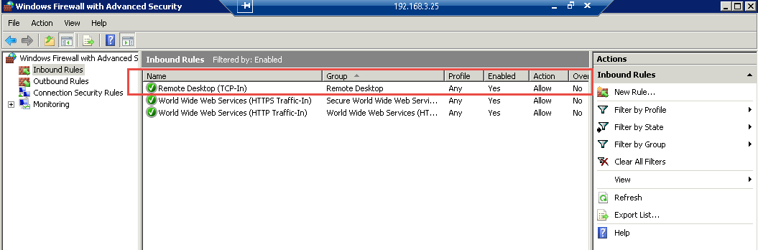

‘

After we disable the **Remote Desktop (TCP-IN)**, the remote connection between Vworkstation and machine 192.168.3.25 becomes unavailable anymore. The reason is pretty clear that when we disable the Inbound rule in firewall, we just block the channel that used for communication between two machines. The result of following picture shows the user’s remote desktop request is declined by remote server due to the firewall settings.

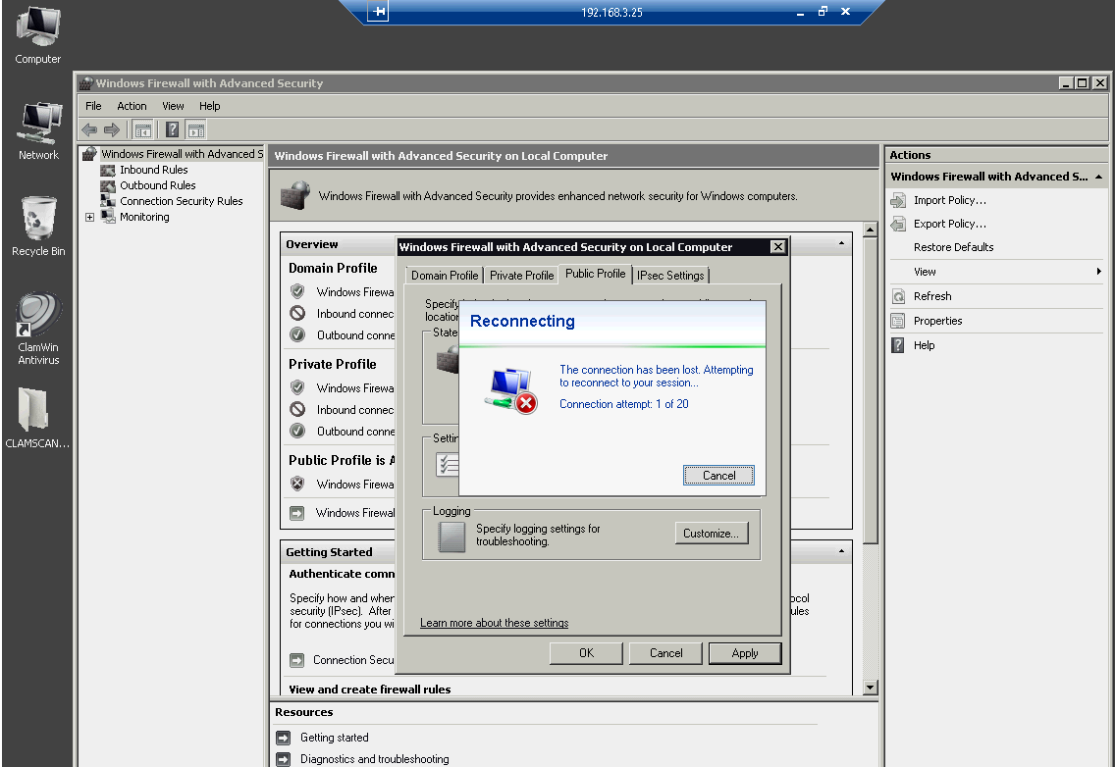

At the last step of normal experiment, we get the following result that after applying firewall rules in instruction, we still have two ports that work properly and all other previous alive ports are disappear. The two left ports are **80/tcp** for **http service** and **3389/tcp** for **ms-wbt-server services**

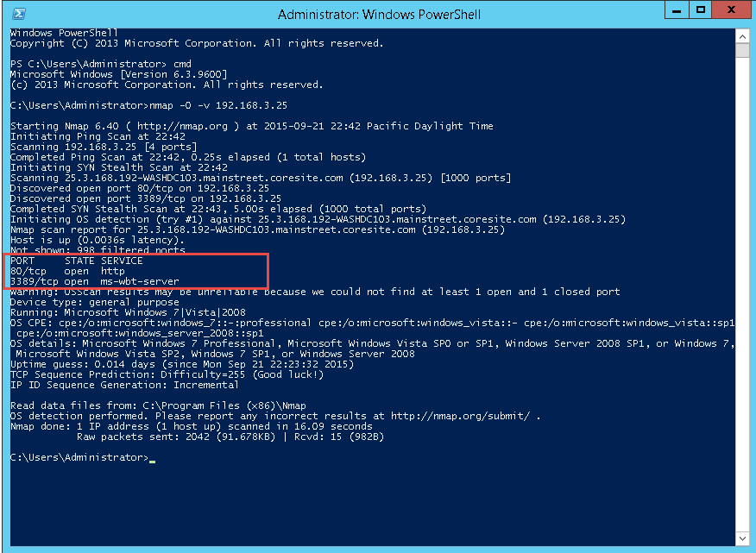

After we blocked the **Remote Desktop (TCP-IN)** inbound rules and retried **Nmap –O –v 192.168.3.25**, we found that no any ports can be detected any more. All the ping requests are declined by remote server IP 192.168.3.25.

